 | INSTITUTE OF COMPUTER TECHNOLOGY  UNIVERSITY OF COLOMBO, SRI LANKA
DEGREE OF BACHELOR OF INFORMATION TECHNOLOGY (EXTERNAL)
Academic Year 2002 – 2nd Year Examination – Semester 3

IT3101: Object Oriented Systems Development

PART 2 – Structured Question Paper

09th March 2002

To be completed by the candidate

BIT Examination Index No:

Important Instructions:

- The duration of the paper is 1 1/2 (one and a half) hours.
- The medium of instruction and questions is English.
- The paper has 4 questions and 16 pages.
- Answer question 1 and any two of the other questions only.
- All questions will carry equal marks.
- Write your answers in English using the space provided in this question paper.
- Do not tear off any part of this answer book.
- Under no circumstances may this book, used or unused, be removed from the Examination Hall by a candidate.
- Note that questions appear on both sides of the paper.
If a page is not printed, please inform the supervisor immediately.

Questions Answered
Indicate by a cross (×), (e.g. 1 ) the numbers of the three questions answered.
 | Question numbers
To be completed by the candidate by  marking a cross (×). | 1 | 2 | 3 | 4
To be completed by the examiners:

×

Based on the following case study answer question 1.

Instructions to the Candidate.
- Please read the case and submit answers to the questions below in the space provided.
- Carefully plan your answers before starting to write.

 | 1) |  |  |  |  | Consider the following Hotel Reservation case study.
 |  |  |  |  |  | A Hotel consisting of 100 rooms needs to computerize their manual system on Room Reservations. The systems analyst who was assigned this project has visited the Hotel and he has gathered the following information about the system. The following text describes his findings.
 |  |  |  |  |  | The 100 rooms available are categorized into different room types and each room type has different rates. The number of rooms of different types and the corresponding rates are as follows:
Room Type Room No. from/to Rate/Night

Single 1 to 60 Rs. 1000
Double 61 to 89 Rs. 1800
Suite 90 to 100 Rs. 5000

 |  |  |  |  |  | A Customer can reserve a room by calling the hotel receptionist. The receptionist will answer the customer’s queries regarding the room types, room rates, modes of payments available and any discounts the customer is entitled to etc. The receptionist will then take the following particulars from the customer, if the customer wishes to proceed with the reservation.
Customer’s name, Contact address, Country, Sex,
Type of accommodation, the period of stay, expected check in date.

 |  |  |  |  |  | Subsequently, the receptionist will check the room availability. If a room is available, the customer is informed about it. If the customer accepts the reservation, a room number is allocated at the same time. The customer is also informed if a room is not available.
 |  |  |  |  |  | A customer can cancel the reservation at any time. It can be done by calling or by sending a fax. The receptionist is also responsible for handling the cancellations.
 |  |  |  |  |  | When the customer checks-in at the hotel on the reserved date, the receptionist will obtain the customer’s desired mode of payment. The customer may be entitled to a discount based on the payment mode selected.
 |  |  |  |  |  | The different payment modes and their discounts are as follows:
Payment Modes Discount

Cash - No discount
Traveller’s Cheques - 2% e.g. AMEX, Cooks etc.
Credit Card - 3% e.g. Diners, Master etc.
Company - Depends upon the company,
E.g. NEC 12%, IBM 10% etc.

 |  |  |  |  |  | The Customer can checkout from the hotel at any time by informing the receptionist. The receptionist will immediately inform the billing Clerk to handle the billing. The details about the payments and other information such as discounts given, company name, kind of traveller’s cheques used, and credit card details etc. are preserved for any future reference.
 |  |  |  |  |  | If the customer needs to extend the stay, he/she may do so by informing the receptionist. The receptionist will check the room availability and the extension is provided if a room is available.
 |  |  |  |  |  | - Following is a Use Case diagram for the given system.
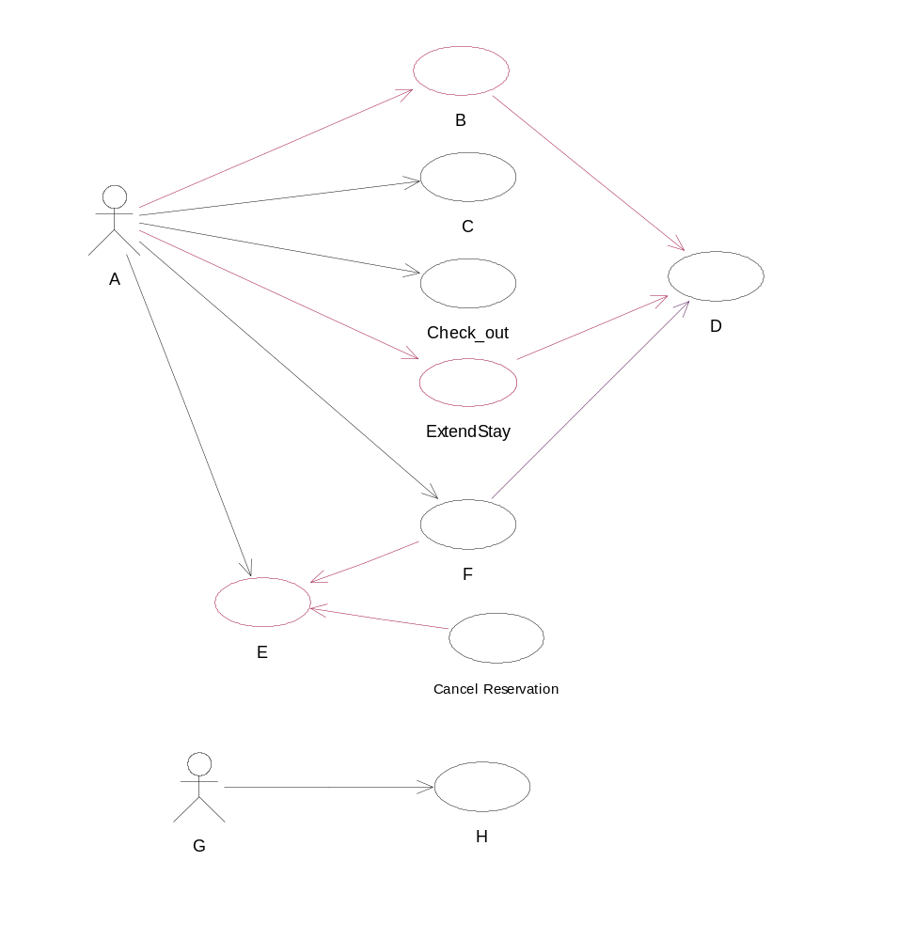

Identify the Actors/Use Cases for labels A-H.

ANSWER IN THIS BOX
Receptionist  Check_in  Reservation  Billing Clerk | CustomerInquiries  Check Room Availability  Make Reservation  Billing

 |  |  |  |  |  |  | (A) (B)
 |  |  |  |  |  |  | (C) (D)
 |  |  |  |  |  |  | (E) (F)
 |  |  |  |  |  |  | (G) (H)
 |  |  |  | (b) Identify the potential classes for the above system.
ANSWER IN THIS BOX
Customer  Reservation  Payments  Cash Payment  CorporateBill Payment | Room  Room Type  Credit Card Payment  Cheque Payment

 |  |  |  | (c) Identify the static relationships between the above classes.
 |  |  |  |  |  |  | ANSWER IN THIS BOX
 |  |  |  |  |  |  | Class name Class name Relationship (UML notation)
Reservation  Reservation  Room  Payments  Payments  Payments  Payments  Reservation | Customer  Room  Room Type  CorporateBill payment  Check Payment  Credit Card Payment  Cash Payment  Payment
  Association
  Association/Aggregation
  Association
  Inheritance
  Inheritance
  Inheritance
  Inheritance
  Association

 |  |  |  | (d) Identify the object(s) responsible for the Use Case F in (a).
 |  |  |  |  |  |  | ANSWER IN THIS BOX
Reservation | Customer
  Room

 |  | 2) |  | - Given below are statements associated with Object Oriented concepts.
Column X | Column Y
(A) Visual modelling | (i) Scenarios developed are examined and prioritized according to certain criteria.
(B) Objectory Software Development Process | (ii) Ensures that different assumptions or decisions are not made in different views of software development.
(C) Iteration planning process | (iii) allows to define an architecture using new and existing components assembled in component architectures .
(D) Scenario walkthroughs | (iv) Way of thinking about problems using models organized around real world situations.
………………… | (v) Occurs during the analysis stage of the system’s life cycle.

You are required to match the statements in Column X with those in Column Y.

ANSWER IN THIS BOX

(iv)  (i) | (iii)  (ii)

 |  |  |  |  |  |  | (A) and (B) and
 |  |  |  |  |  |  | (C) and (D) and
- Write down whether the following descriptions are true or false.
ANSWER IN THESE BOXES

- UML is not a programming language. (true/false)
True

True

False

True

False

 |  |  |  | - Reusability is an advantage in Object Oriented Approach over the Structured approach in Systems analysis and design (true/false)
 |  |  |  | - A Collaboration diagram shows object interactions arranged in time sequence. (true/false)
 |  |  |  | - When grouping classes into packages, the classes that are related by aggregation can be grouped into the same package. (true/false)
 |  |  |  | (v) When using OOAD artefacts to assign team responsibilities on a project, teams can be divided according to the layers in the software architecture. (true/false)
 |  |  |  | (c) What would the output be of the following program, if x=3 and y=5?
#include <iostream.h>

void disp();
int sum(int,int);

void main()
{
int x,y,s;
cin>>x;
cin>>y;
s=sum(x++,y++);
cout<< s <<'\n';
s=sum(x++,y++);
cout<<s<<'\n';
disp();
}

static int c=0;

int sum(int a,int b)
{
c = a + b + c;
return(c);
}

void disp()
{
cout<<c;
}

ANSWER IN THIS BOX

8
18
18

 |  |  |  | (d) If disp() function call in the main function is replaced with the statement cout<<c , what would the output be?
ANSWER IN THIS BOX

Compilation error : c undeclared identifier.

 | 3) |  |  | - Consider the given flow of events and the sequence diagram for a ManageSales Scenario of a certain unspecified Supermaket system. This Scenario begins when a customer arrives at the counter (Sales Centre) with his Items. For the time being, only Cash payments are entertained. Note that the operations 1 to 5 in the sequence diagram will be repeated until no more items are left to enter.
 |  |  |  | Main Flow  REPEAT  Enter ProductCode , Quantity.  System gets the relevant Item Object  If Item Object Cannot be found. THEN (E-1)  Re-enter ItemCode .  Else Process  Create Sales Item Object  UNTIL there are no more Items to enter  Obtain total Sales value  Enter Customers Cash amount  IF Insufficient Cash Amount (E-2)  Re-Enter Customers Cash amount  ELSE  Create a Payment Object  Obtain Balance due to customer |  |  |  |  | Alternate Flows  E-1 Message “Invalid Product Code”  E-2 : Message “Insufficient Cash amount ”
 |  |  |  | 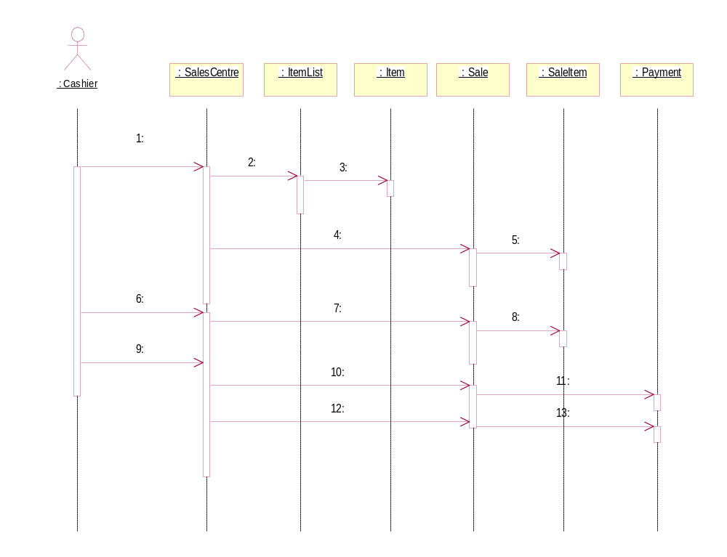
Consider the list of messages given below.

- CreateSaleItem(Item, Qty) | - EnterSalesItem(ItemCode, Quantity)
- GetSalesTotal( ) | - CompleteSale( )
- MakePayment(CashAmount) | - getItem(ItemCode)
- getItem(ItemCode) | - getBalance( )
- MakePayment(SalesAmount) | - Create(Item, Qty)
- getAmountPaid( ) | - getSubTotal( )
 | - MakePayment(CashAmount)

Fill in each bank with the appropriate message from the list.
ANSWER IN THIS BOX

g  k/a  m/c  f | d/i  h  c/m
  I/d  b  e | A/k  l  j

 |  |  |  |  |  |  | 1. 2. 3. 4.
 |  |  |  |  |  |  | 5. 6. 7. 8.
 |  |  |  |  |  |  | 9. 10. 11. 12.
 |  |  |  |  |  |  | 13.
- Behavioural diagrams are used to visualize, specify, construct and document the dynamic aspects of a system.
Name 3 Behavioural diagrams in UML.

ANSWER IN THIS BOX

Use Case diagram  Collaboration diagram  Activity diagram | Sequence diagram  Statechart diagram

(c) The following is a Class Circle drawn using UML notations
Circle
# position :integer
# visible : Boolean

+isVisible()
-setPosition(newPos)

 |  |  |  | Identify the attributes, services and their visibility.
 |  |  |  |  |  |  | ANSWER IN THIS BOX
 |  |  |  |  |  |  | Attributes/Services Visibility
  Position(attritute)  Visible(attribute)  isVisible(service)  SetPosition(service) | protected  protected  public  private
(d) The Following shows use cases for placing an order.
When placing an Order, it is necessary to supply, customer information, information about the ordered products and arrangements for mode of payment (can be credit or cash). Most of the time, the customers are sure about the products to be ordered, but, sometimes, they request for a product catalogue.

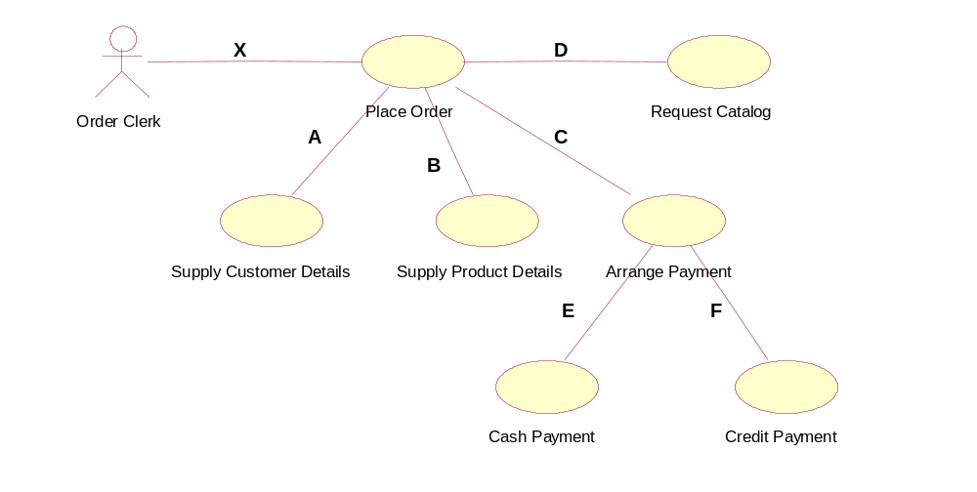
The use cases participate in relationships between themselves (A to F) These relationships can be any one of the following:

- Communicate
- Extend
- Generalization
- Include
Write down the relationships from A to F in spaces given below.

E.g. X --------i-----------
ANSWER IN THIS BOX

iv  iv  ii/iii | iv  ii  ii/iii

 |  |  |  |  |  |  | A ------- ---------- B ------- ----------
 |  |  |  |  |  |  | C -------- --------- D ------- ----------
 |  |  |  |  |  |  | E -------- --------- F -------- -------
 |  | 4) |  | A class Circle has to be defined which knows about the radius (float type) and the color (int type) it needs to be drawn.(number between 0-255 will represent the color). When an object is declared, a Circle with given radius and of color 0 should be created. It should have public methods as setCircleInfo() which sets the radius of the circle to a given value and its color to 255, getRadius() which returns the radius, and displayArea() which will display the area of the circle. displayArea() method will utilize a private method calculateArea() which will calculate and return the area of the circle (Area of a circle = 3.14*radius*radius).
 |  |  |  | (i) Write down the C++ definition for the class circle. (Method implementation is not needed)
 |  |  |  |  |  |  | ANSWER IN THIS BOX
# include <iostream.h>
class Circle
{
private :
float radius;
int colour;
float calculateArea(void); //area 3.14*radius*radius
public :
Circle(float r);//set the value to r and color to 0
void setCircleInfo(float r);//set radius to r and color to 255
float getRadius(void); //return the radius
void displayArea(void);//display the area using calculateArea()
};

 |  |  |  | (ii) Implement the methods using C++.
 |  |  |  |  |  |  | ANSWER IN THIS BOX
Circle::Circle(float r)
{
radius=r ;
colour=0 ;
}

double Circle::calculateArea(void)
{
return (3.14*radius*radius);
}

void Circle :: setCircleInfo(float r)
{
radius=r ;
colour= 255 ;
}

float Circle :: getRadius(void)
{
return radius;
}

void Circle :: displayArea(void)
{
cout << “The Area of the Circle = ” << calculateArea();
}
 |  |  |  | (iii)Overload the method setCircleInfo () so that it can set the radius and color to given values.
 |  |  |  |  |  |  | ANSWER IN THIS BOX
void Circle :: setCircleData(float r, int c)
{
radius=r ;
colour= c ;
}

(iv) Fill in the blanks in the following main() function.
void main()
{

ANSWER IN THIS BOX
//create a MyCircle1 object with radius equal to 7 units and of color 0 and MyCircle2 with radius equals to 14 units and of color 100.

Circle MyCircle1(7);
OR
Circle MyCircle1(7,0);

AND
Circle MyCircle2(14,100);

//Set the radius of MyCircle1 to 21 units and color to 255.
MyCircle1.SetCircleInfo(21);
OR
MyCircle1.SetCircleInfo(21,255);

//Display the Area of MyCircle2

MyCircle2.displayArea();

//Set the radius of MyCircle2 to 40 units and its color to 100

MyCircle2. SetCircleInfo(40,100);
}

 |  |  |  | (v) Overload the constructor so that a circle object with a given radius and color can be created.
 |  |  |  |  |  |  | ANSWER IN THIS BOX
Circle :: Circle(float r, int c)
{
radius=r ;
colour=c ;
}

 |  |  |  | ********

